Budget Forms and Information Revision Summary

2025-2026

**Estimating M&O Worksheet**

* Revised 4/15/2025:
  + FY 2026 Estimating M&O Worksheet – Updated ‘Health Insurance Per Support Unit’ and ‘Discretionary Per Support Unit’ amounts (Reversed the dollar amounts shown on the original form) (Should be: General Discretionary Per Support Unit =$23,472, Health Insurance Discretionary Per Support Unit =$21,902)

**Salary Based Apportionment**

* Revised 4/15/2025:
  + FY 2026 Salary Based Apportionment **Charter** template – Updated ‘Actual FTE – Instructional’ Formula
  + FY 2026 Salary Based Apportionment **Charter** and **School District** templates – Updated Career Ladder cell amounts:

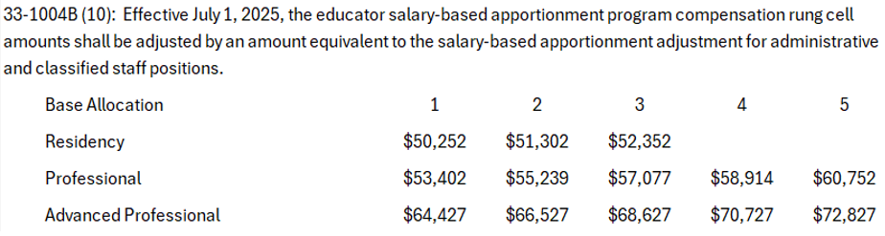

* Revised 5/5/2025
  + FY 2026 Salary Based Apportionment **Charter** and **School District** templates - Staffing percentage was updated to 9.5%
  + FY 2026 Salary Based Apportionment **Charter** and **School District** templates - Updated the cell reference for the average salary on the Virtual FTE tab

**Combining Revenues and Expenditures Form**

* Revised 5/6/2025
  + FY 2026 Combined Revenues and Expenditures - Updated the Budget Revenues tabs removing the code 437000 – Lottery/Additional State Maintenance

**Budget Revenues Form**

* Revised 5/6/2025
  + FY 2026 Revenues - Updated the Budget Revenues Form removing the code 437000 – Lottery/Additional State Maintenance

**Budget Expenditures Form**

* Revised 6/4/2025
  + FY 2026 Expenditures – Updated the Budget Expenditures Form by deselecting all tabs