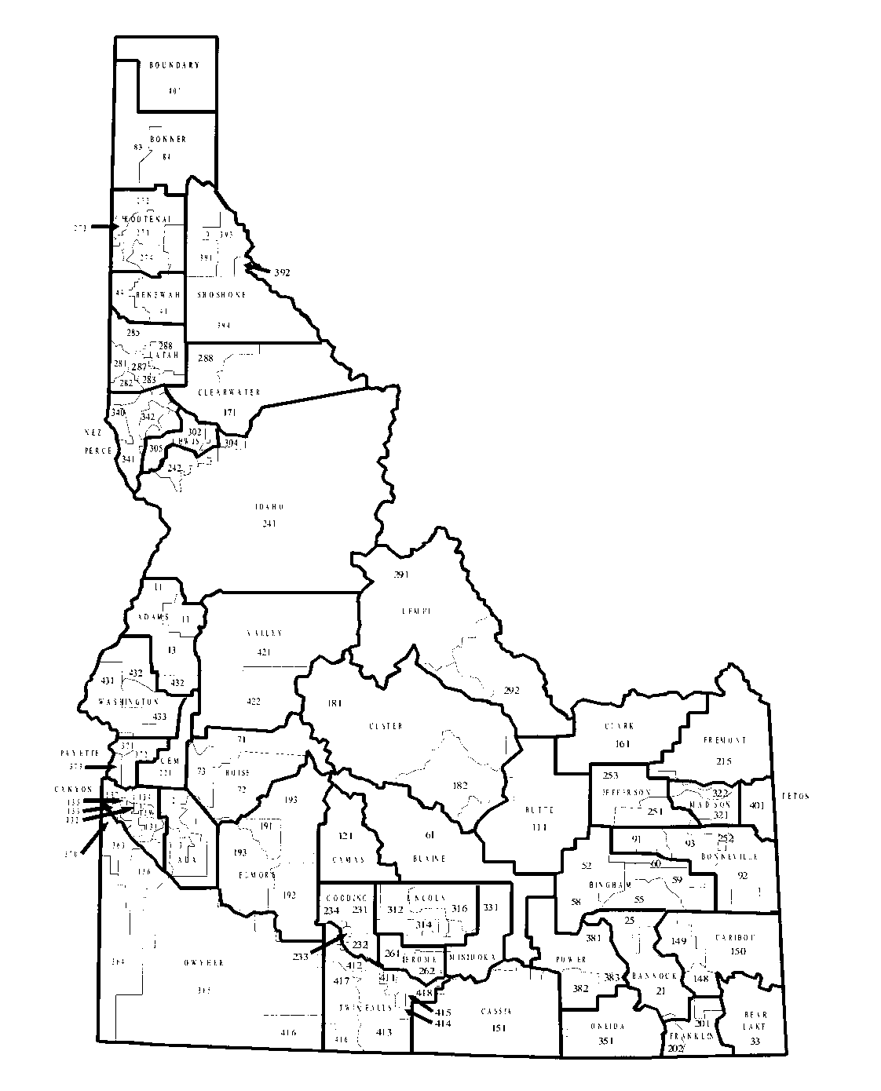


SCHOOL DISTRICT BUDGET
2025 – 2026

Name of School District/Charter School

Organization Number

County

Debbie Critchfield
IDAHO DEPARTMENT OF EDUCATION
P.O. BOX 83720

BOISE, 83720-0027

