  What is a School-Parent Compact?
  Jointly Developed
  ESSA SEC1116(d)
  Activities
  to Build Partnerships
  Communication about Student Learning
  ESSA SEC1116(d): (1), (2), (2C), (2D)
  Cover
    - 2025-2026
  
  REVISED xx/xx/xxxx

  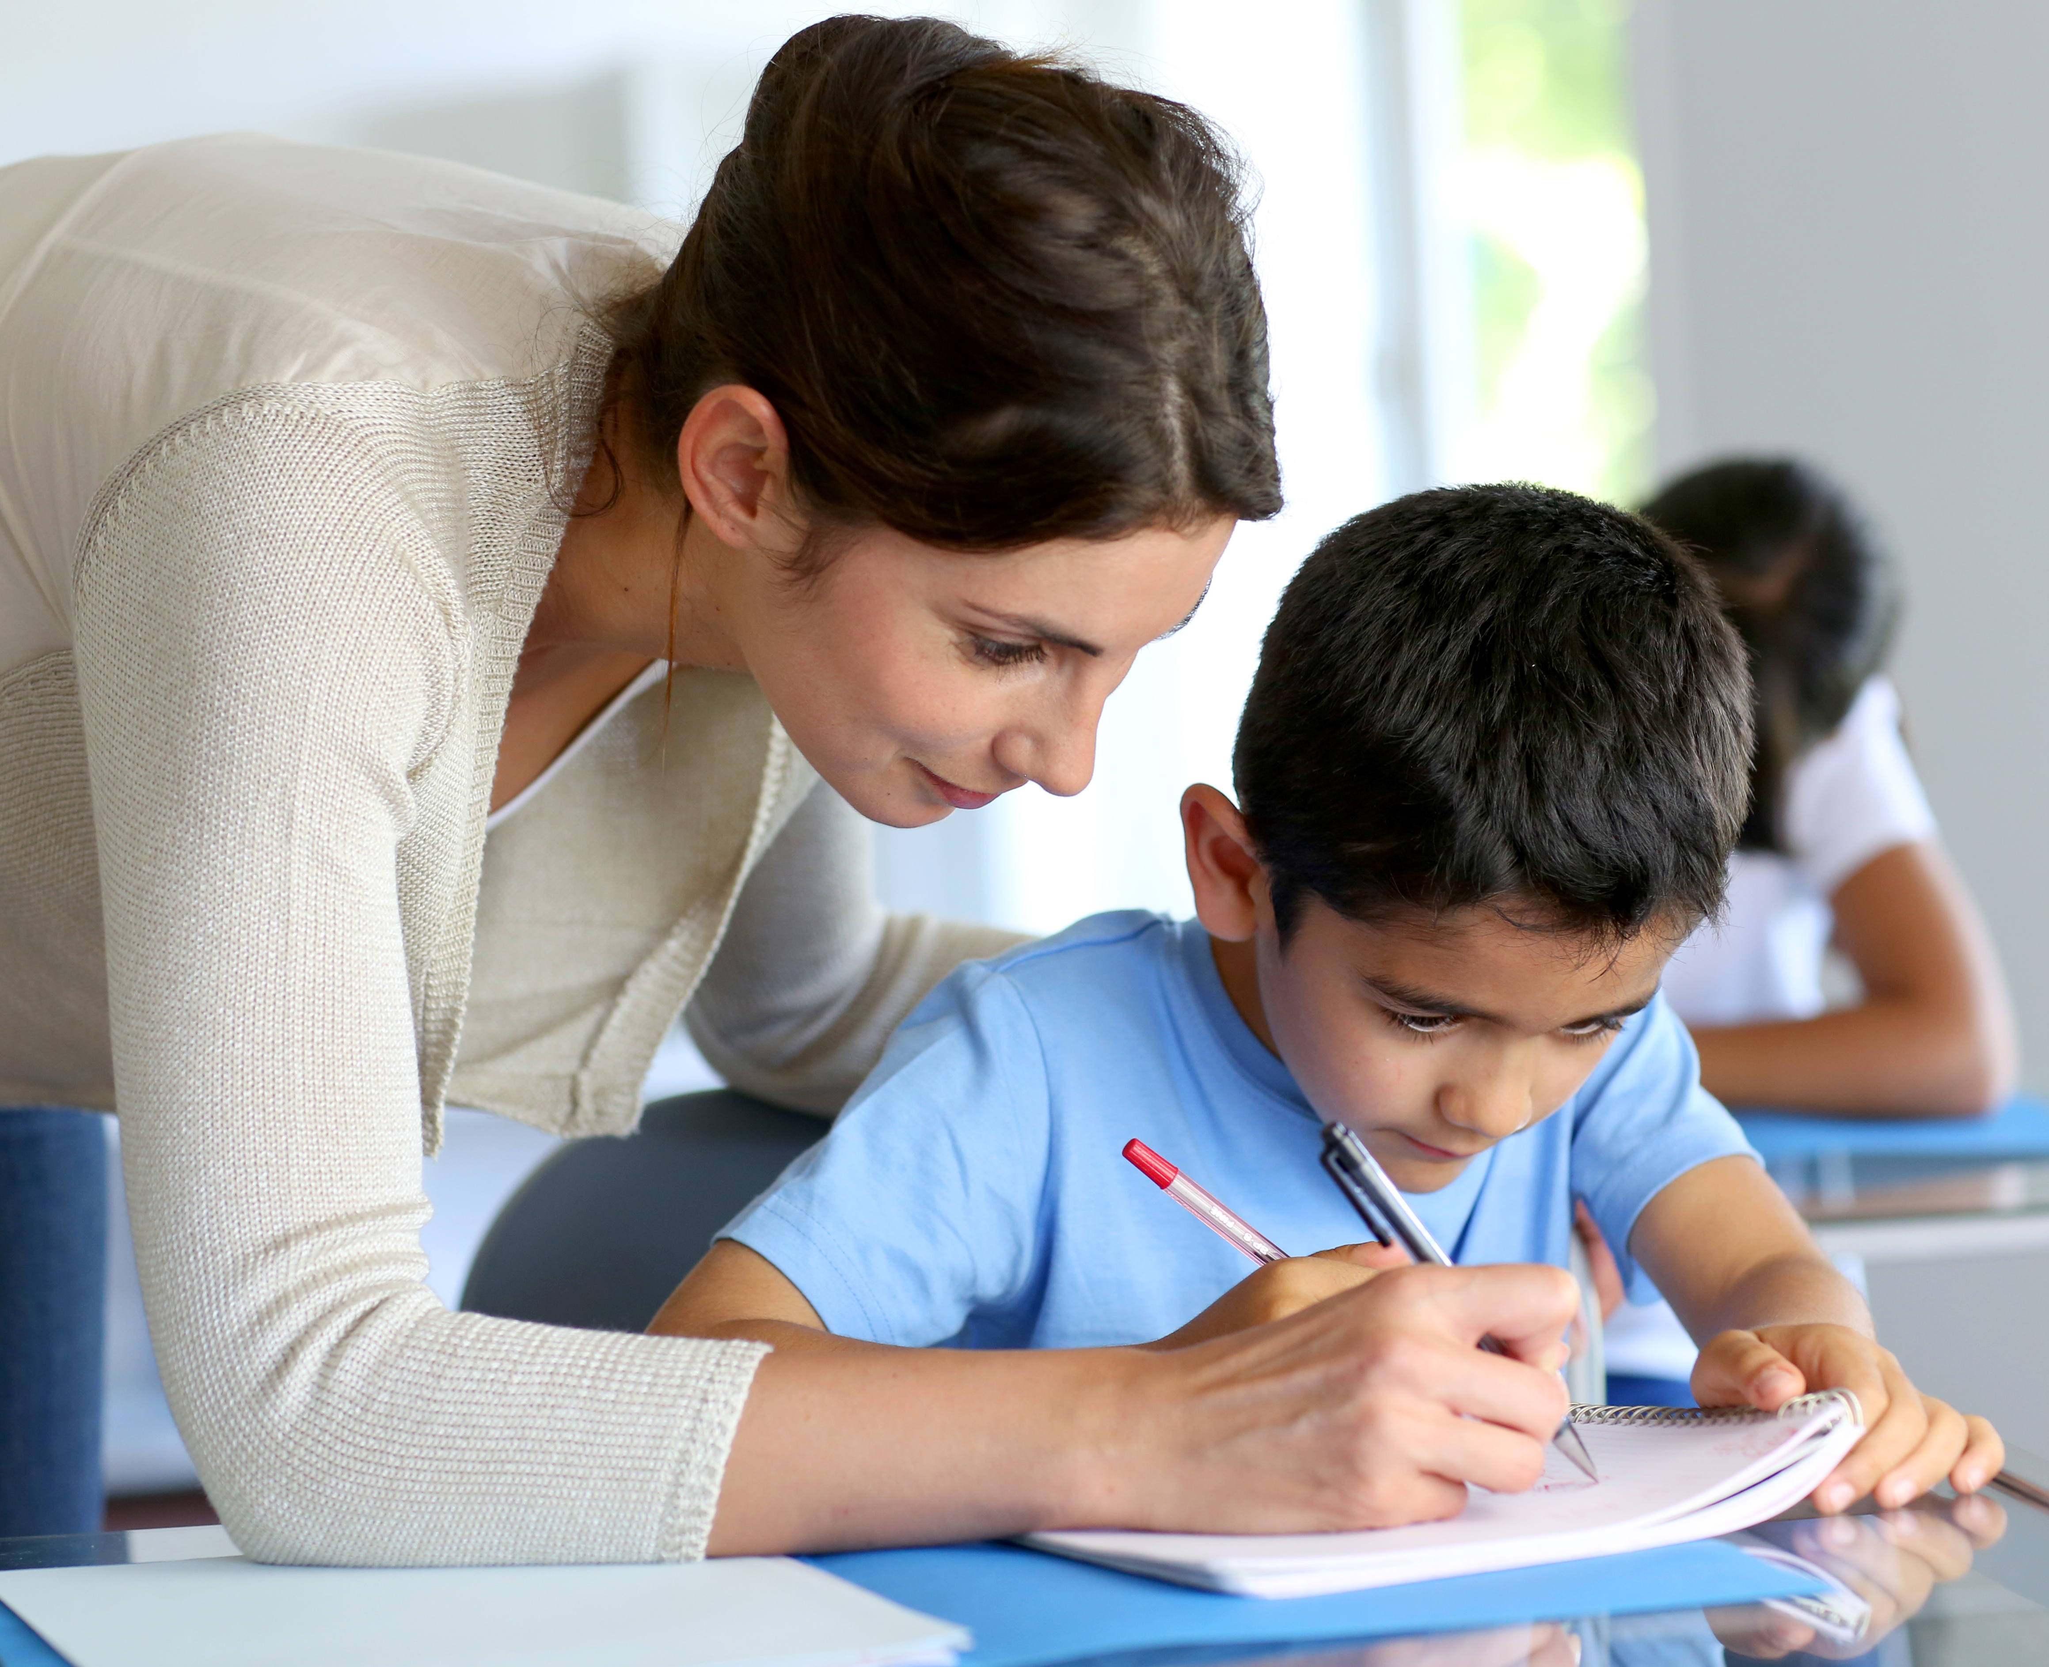
  Goals for Student Achievement
  We've created styles that let you match the formatting in this brochure with just a click. On the Home tab of the ribbon, check out the Styles gallery.
  District Goal(s)
  To try out other looks for this brochure, on the Design tab of the ribbon, check out the Themes, Colors, and Fonts galleries.
  Have your own school fonts or colors? No problem! Those galleries give you the option to add your own.
  School Goal(s) and Focus area(s)
  Teachers, Parents, and Students—Together for Success
  Teacher/School Responsibilities
  (List/Describe activities/strategies provided to parents to build the parent’s capacity to support their student’s learning at home.)
  ESSA SEC1116(d): (2A), (2B), (2D)
  Student Responsibilities
  (List/Describe specific academic strategies the student will complete to be responsible for their own learning.)
  ESSA SEC1116(d): (1)
  Family Responsibilities
  (List/Describe specific activities linked to learning that parents/families will implement to support their child’s learning to achieve the identified school academic goals.)
  ESSA SEC1116(d): (1), (2A)
  Contact Us
  School Name
  [Address]
  [City, ST ZIP Code]
  [Telephone]
  [Email]
  Visit us on the Web:
  [Web Address]

