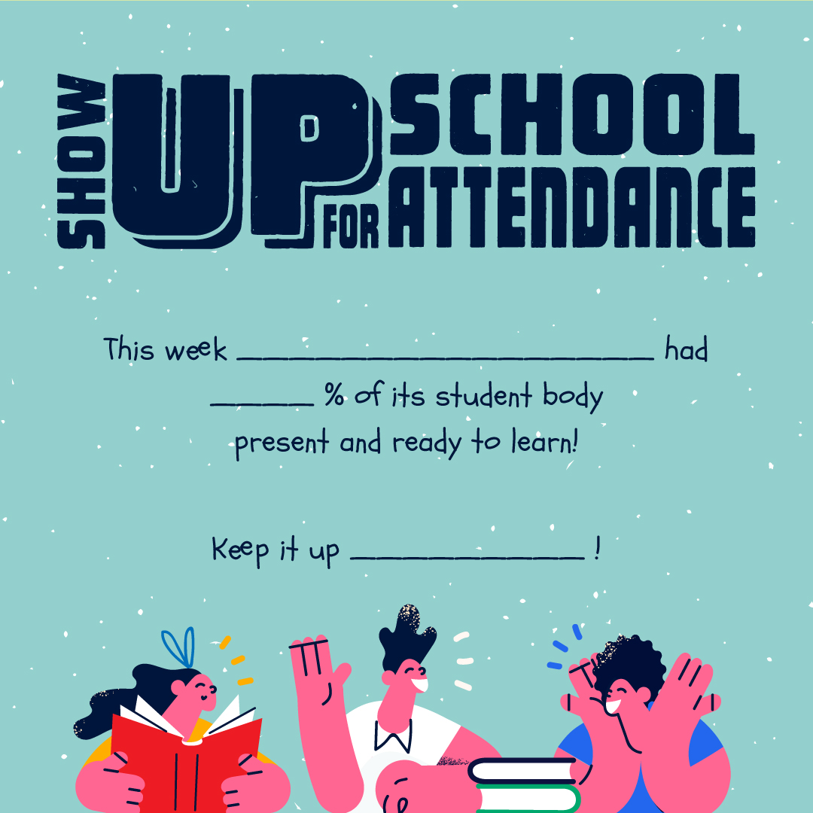
{MASCOT}
{%}
{NAME OF SCHOOL}

